**Android Phone**

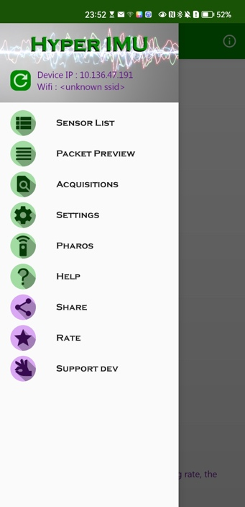1. The software interface

Here we need “Sensor List” and “Settings”.

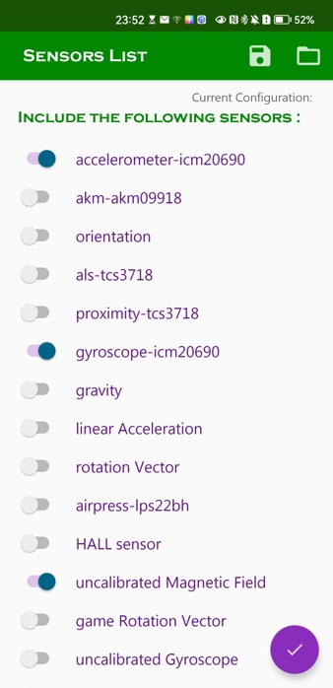2. Sensor List

Three indicators need to be collected, that are accelerations, angular velocities, and magnetic field.

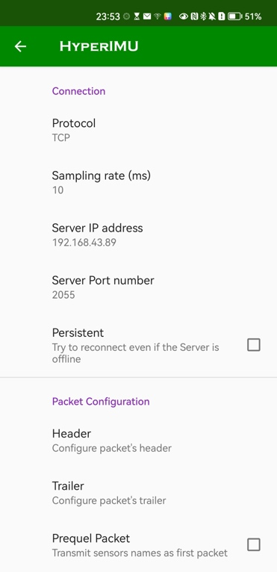3. Settings

Transmission protocol and sampling rate settings. The server IP address corresponds to your computer IP address (your computer and your phone need to be in the same LAN), and the server port is set by yourself.

**iPhone**

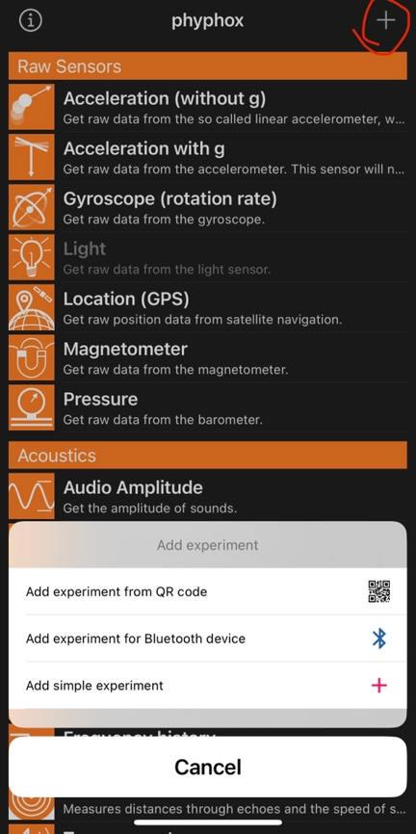1. Add a simple experiment

2. Choose what to collect

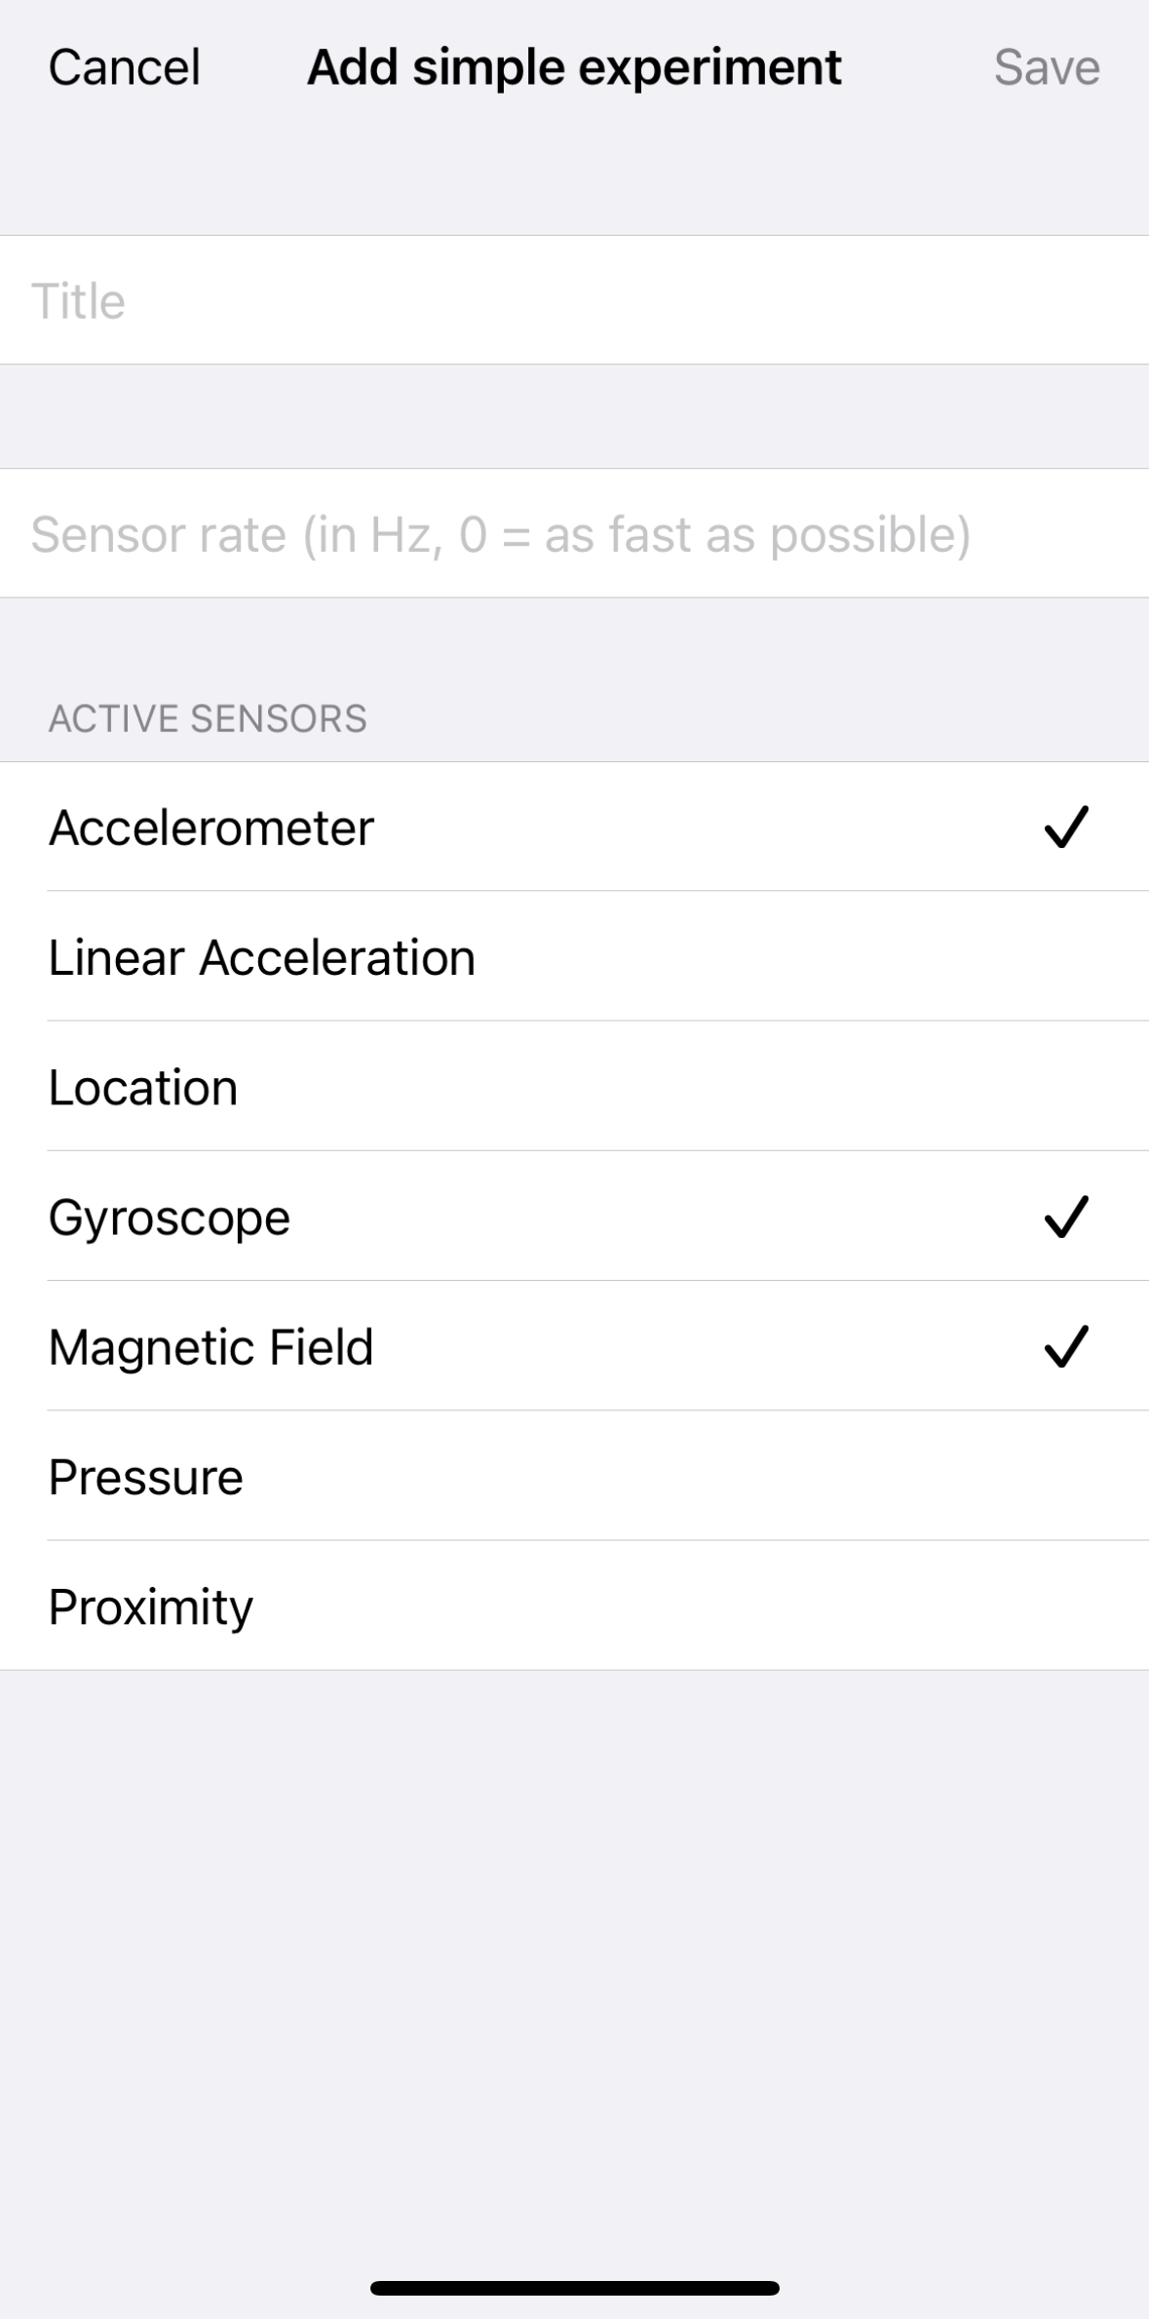

As for the sensor rate, 100Hz is recommended. You are encouraged to use other rate instead.

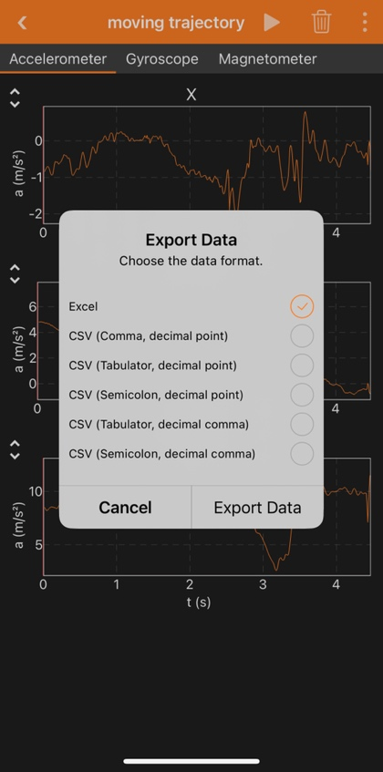3. Data collection and exportation

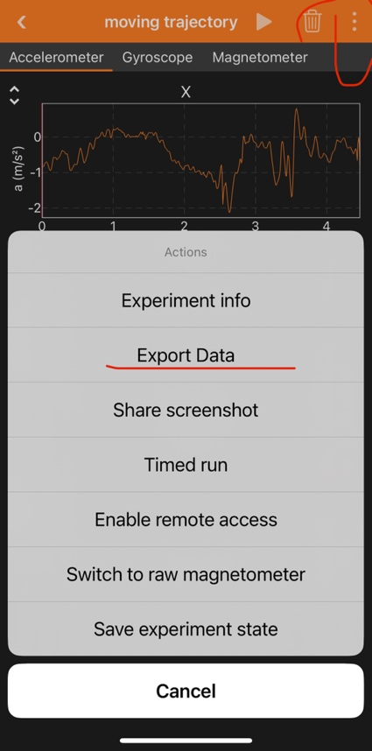After the data collection in the experiment, you need to export the data. The recommended file format is Excel, as it will contain all of the data in one file.